JIM RICHTER

JimRichter.com
jim@JimRichter.com
317-319-9299

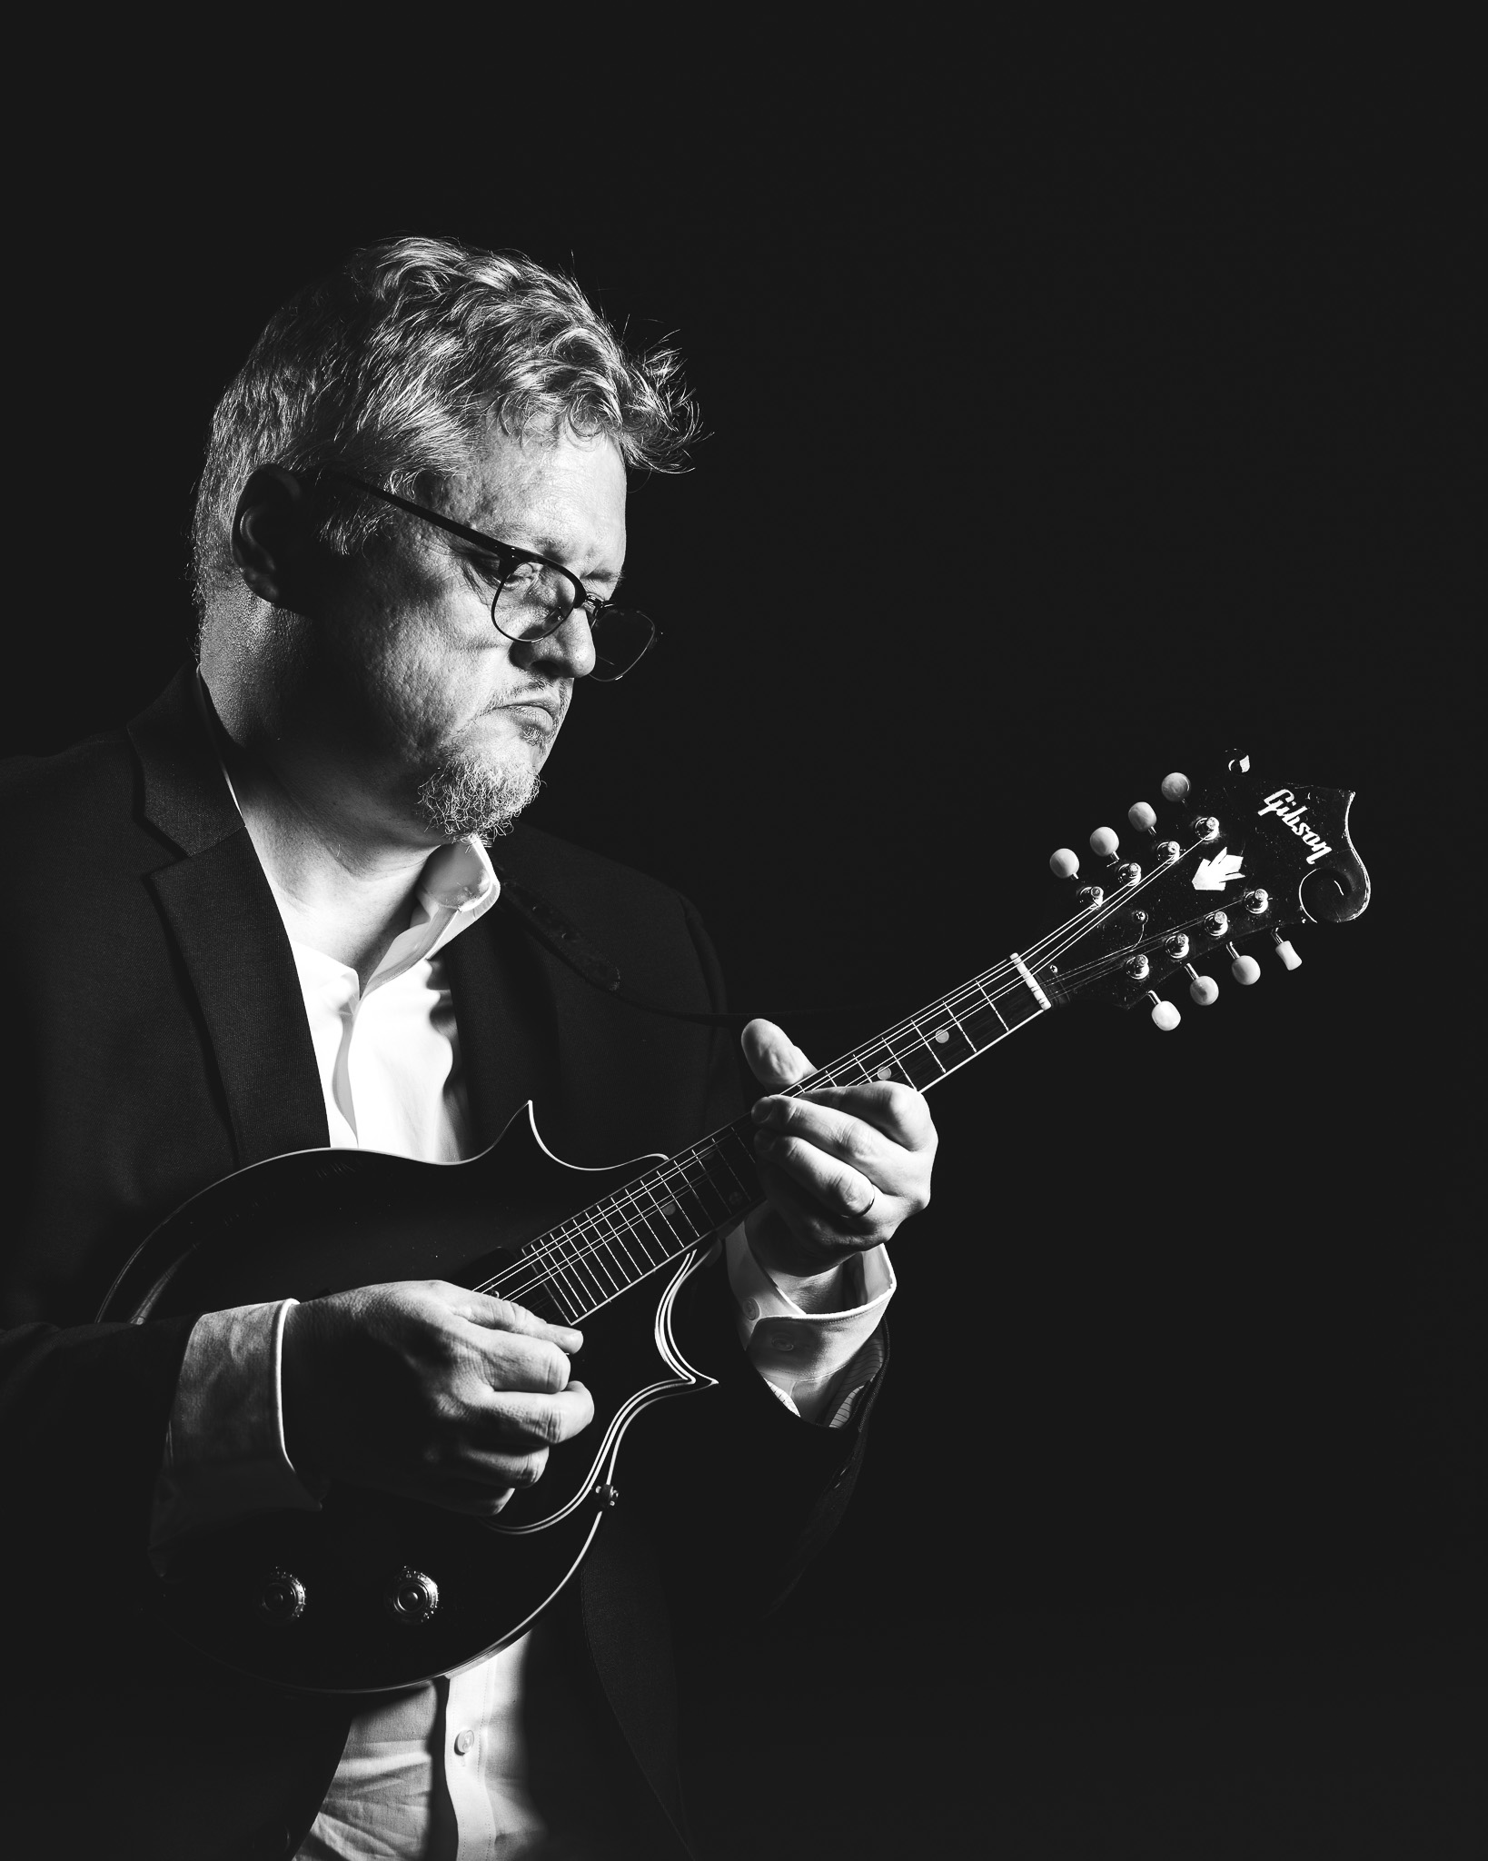
Jim Richter is a multi-instrumentalist (mandolin, banjo, guitar) who over the last 40 years has focused on roots-based American music with a special focus on traditional electric and acoustic blues. Jim started his musical life as a bluegrass banjoist, followed by many years as an electric guitarist specializing in the styles of Freddy King and Hollywood Fats. However, the last two decades, blues mandolin has truly been the niche Jim was meant to embrace. Though respectful of the historical blues mandolin pioneers, Jim has sought to expand blues mandolin expression and repertoire though leveraging his background as an electric blues guitarist. Jim has become recognized as one of the leaders in this area. Also, Jim’s extensive knowledge of guitar-based classic rock has led him to transcribe and arrange many tunes for mandolin that show how versatile the mandolin can be in reimagining rock tunes without “bluegrassifying” them.

Jim is most proud of the work he has done in mandolin education especially for adult learners. Partnering with Don Julin, Jim developed the Jim Richter Mandolin Camp for the Rest of Us that focuses on three areas: 1) mandolin instruction for the non-bluegrasser, 2) adult learners who need a different approach to instruction and 3) teaching students how to harness what they already know to build self-efficacy and immediate use of that knowledge while playing with others. This camp enters its 10th year in 2023 with Don Julio returning and Jim’s mentor Mike Compton. Jim has also held the blues/rock mandolin chair at Mandolin Camp North in Massachusetts for several years, as well as the Metamora Mandolin Gathering.

Jim’s discography includes his own In-Tuition series, The Road Home (tribute to Butch Baldassari), Tribute to Yank Rachell, Hootenanny with Gordon Bonham (live concert DVD), and Too Damn Cold by the Forecasters. Jim is also a licensed mental health counselor who directs a mental health center in Indianapolis, Indiana and was a doctoral candidate in psychology before deciding enjoying life was more important.

